68480 - [Validation] C# unions in component parameters and prerendered state
1. Environment Metadata
1.Build tested: .NET 11 Preview (Issue #68480 Validation Sample)
2. NET SDK: dotnet-sdk-11.0.100-preview.7.26381.103-win-x64
3. Configuration: Debug and Release (Published)
4.OS: Windows 11
5.Browser: Edge
6.IDE: Visual Studio 2026 Preview
7.Render modes: Interactive Server, Interactive WebAssembly, Interactive Auto (Cold), Interactive Auto (Warm)
8.Outcome:
PASS - All required validation scenarios completed successfully across Debug and Published builds. Union component parameters, persisted prerendered state restoration, nullable unions, classified/unclassified record unions, nested unions, active-case mutation, and unsupported query-string binding behaved as expected. No functional issues were identified. Two observations were recorded: (1) Razor attribute DX friction when a union contains a string case and (2) unsupported query-binding exception wording could more explicitly mention union-type limitations.
2. Publish Evidence
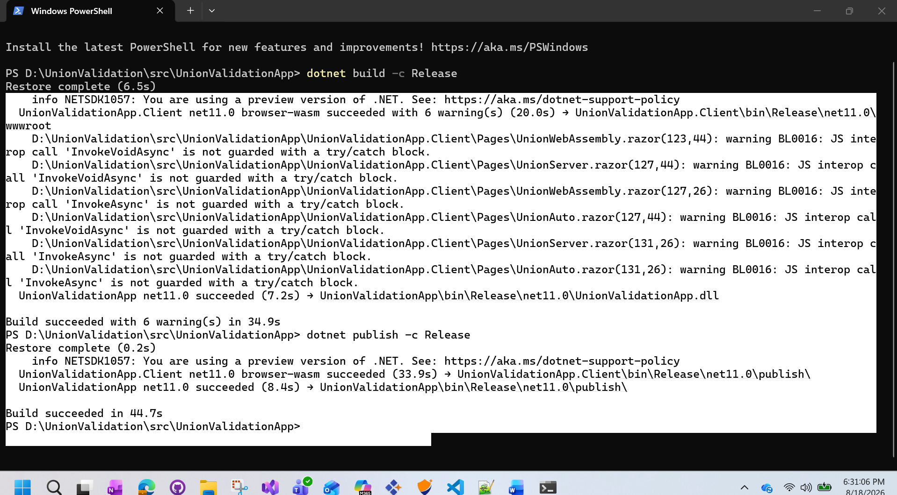

3.Findings and Observations
ID | Classification | Observation | Impact
OBS-01 | DX Friction | A union parameter containing a string case accepted ActiveUnion="primitiveUnion" as a literal string value instead of the intended parent field reference. Using ActiveUnion="@primitiveUnion" correctly passed the field value. | Developer experience issue. Easy to misunderstand during component authoring, but behavior is consistent with Razor expression rules.
OBS-02 | Diagnostic Wording Observation | Unsupported query-string binding failed with InvalidOperationException: Querystring values cannot be parsed as type 'UnionValidationApp.Client.Models.IntOrString'. The message identifies the binding source and target type but does not explicitly state that union types are unsupported for query-string binding. | Minor diagnostic wording improvement opportunity. The error is actionable and prevents silent incorrect binding.

4.Scenario Based Test Cases
S.No | Scenario | Status | Comments
 | Server - Initial rendering (Wrong Markup) | ✅ PASS | Razor requires @ prefix for union parameters: ActiveUnion="@value" not ActiveUnion="value"
2 | Server - Initial rendering | ✅ PASS
3 | Server - After clicking Change Active Cases | ✅ PASS
4 | Server - Static-to-interactive transition | ✅ PASS
5 | WASM - Initial rendering | ✅ PASS
6 | WASM - After clicking Change Active Cases | ✅ PASS
7 | WASM - Static-to-interactive transition | ✅ PASS
8 | Interactive Auto - Cold - Initial rendering | ✅ PASS
9 | Interactive Auto - Cold - After clicking Change Active Cases | ✅ PASS
10 | Interactive Auto - Cold - Static-Interactivity transition | ✅ PASS
11 | Interactive Auto - Warm - Initial rendering | ✅ PASS
12 | Interactive Auto - Warm - After clicking Change Active Cases | ✅ PASS
13 | Interactive Auto - Warm - Static-Interactivity transition | ✅ PASS
14 | Static - Unsupported query-string binding | ✅ PASS | Exception correctly thrown naming union type IntOrString; error message quality validates binding is not supported
15 | Server Published - Initial rendering | ✅ PASS
16 | Server Published - After clicking Change Active Cases | ✅ PASS
17 | Server Published - Static-to-interactive transition | ✅ PASS
18 | WASM Published - Initial rendering | ✅ PASS
19 | WASM Published - After clicking Change Active Cases | ✅ PASS
20 | WASM Published - Static-to-interactive transition | ✅ PASS
21 | Interactive Auto - Cold Published - Initial rendering | ✅ PASS
22 | Interactive Auto - Cold Published - After clicking Change Active Cases | ✅ PASS
23 | Interactive Auto - Cold Published - Static-to-interactive transition | ✅ PASS
24 | Interactive Auto - Warm Published - Initial rendering | ✅ PASS
25 | Interactive Auto - Warm Published - After clicking Change Active Cases | ✅ PASS
26 | Interactive Auto - Warm Published - Static-to-interactive transition | ✅ PASS
27 | Static Published - Unsupported binding | ✅ PASS
28 | WASM Trimmed Published Assembly - Initial render | ✅ PASS

